FINAL PROJECT REPORT

SUBMITTED BY
NIRANJAN AMAR PATIL
COLLEGE NAME
DR. D. Y. PATIL PRATISHTHAN'S COLLEGE OF ENGINEERING, SALOKHENAGAR, KOLHAPUR

BRANCH
COMPUTER SCIENCE AND ENGINEERING (DATA SCIENCE)

ROLL ID
B.TECH 39

PROJECT NAME

The Food Delivery Analytics: Customer Behaviour & Operational Insights

Final Project Report Template
- Introduction
  - Project overviews
  - Objectives
- Project Initialization and Planning Phase
  - Define Problem Statement
  - Project Proposal (Proposed Solution)
  - Initial Project Planning
- Data Collection and Pre-processing Phase
  - Data Collection Plan and Raw Data Sources Identified
  - Data Quality Report
  - Data Exploration and Pre-processing
- Data Visualization
  - Framing Business Questions
  - Developing Visualizations
- Dashboard
  - Dashboard Design File
- Report
  - Story Design File
- Performance Testing
  - Utilization of Data filters
  - No of Calculation Field
  - No of Visualization
- Conclusion/Observation
- Future Scope
- Appendix
  - Source Code(if any)
  - GitHub & Project Demo Lin

Final Project Report

1. Introduction
1.1. Project overviews
The Food Delivery Analytics: Customer Behaviour & Operational Insights project evaluates end-to-end food delivery performance to convert raw order data into actionable business intelligence. Using Tableau, this project processes key data across metrics including total revenue, average order value (AOV), delivery time, repeat ordering, rain-impact operations, surge fees, cuisines, and customer mood. The system delivers an interactive, multi-dashboard visual tool equipped with key performance indicators (KPIs), dynamic filters, and storytelling features to help decision-makers identify revenue drivers, streamline delivery logistics, and optimize customer retention strategies.

1.2 Objectives
- Analyze total revenue, average order value (AOV), and category-level spending across different cuisines and restaurant types to pinpoint primary revenue opportunities.
- Measure repeat-order rates and evaluate the impact of customer mood and order history on overall customer retention.
- Evaluate delivery logistics and operational bottlenecks caused by increasing order volume and shifting operational conditions.
- Quantify the impact of weather conditions—specifically rain—on delivery times and surge fee applications.
- Build interactive Tableau dashboards and dynamic KPI visualizers to present raw data as structured, real-time insights for stakeholders.

2. Project Initialization and Planning Phase
2.1. Define Problem Statement

Main Problem Statement
Food delivery businesses need a clear and interactive way to understand revenue performance, average order value, customer ordering behaviour, repeat orders, cuisine and restaurant performance, delivery efficiency, and the impact of weather on operations. Without a structured analytical view, stakeholders may find it difficult to identify revenue opportunities, customer retention patterns, delivery bottlenecks, and operational challenges, which can affect business growth and customer experience.
Problem Statement (PS) | I am (Customer) | I’m trying to | But | Because | Which makes me feel
PS-1 | A food delivery business manager | Understand revenue, AOV, and overall business performance | It is difficult to quickly identify the key revenue and order-value patterns | Customer spending and ordering behaviour varies across food categories and restaurant types | uncertain about where to focus revenue-growth efforts
PS-2 | A Customer Analytics Manager | Understand repeat-order behaviour and customer mood | It is difficult to identify patterns associated with repeat ordering | Customers have different ordering behaviours and experiences | Unsure how to improve customer retention
PS-3 | A Food Delivery Operations Manager | Understand delivery performance and identify operational bottlenecks | Delivery time can vary with order volume and operational conditions | Increasing order volumes can put pressure on delivery operations | Concerned about delays and their impact on customer experience
PS-4 | A Food Delivery Operations Manager | Understand the effect of rain on delivery operations | It is difficult to quantify how rain affects delivery time and surge fees | Weather conditions can create additional delivery challenges | Concerned about longer delivery times and increased operational costs
PS-5 | A Restaurant / Business Partner | Identify high-performing cuisines and restaurant types | It is difficult to compare revenue performance across categories | Customer preferences and spending differ across cuisines and restaurant types | Unsure which food categories and restaurant types deserve greater attention

2.2 Project Proposal – Proposed Solution

Project Proposal
Project Overview | Details
Objective | This project analyzes food ordering behaviour using Tableau to understand customer ordering patterns, revenue performance, delivery efficiency, repeat-order behaviour, weather-related operational factors, cuisines, restaurant types, and customer preferences. Interactive dashboards and visualizations are used to convert raw food-ordering data into meaningful business insights.
Scope | To analyze food ordering data and identify important patterns in orders, revenue, average order value, delivery time, repeat orders, customer behaviour, cuisines, restaurant types, customer mood, and weather conditions, and present the findings through interactive Tableau dashboards.
Problem Statement | Food delivery businesses generate large amounts of order and customer data, but it can be difficult to quickly identify the factors affecting revenue, order value, delivery performance, repeat ordering, and customer behaviour. A clear and interactive analytical dashboard is required to convert this data into actionable business insights.
Impact | The analysis can help food-delivery stakeholders understand which cuisines and restaurant types generate higher revenue, how delivery time varies with order volume, how weather conditions affect operations and surge fees, and which customer behaviours are associated with repeat orders. These insights can support operational improvements, customer-retention strategies, and better business decisions.
Approach | The food-ordering dataset is connected to Tableau and analyzed using calculated measures, KPI visualizations, charts, filters, and dashboards. The project examines key business metrics such as Total Revenue, AOV, Average Delivery Time, Repeat Order %, and operational bottlenecks. Additional analysis is performed to understand the relationship between rain, delivery time, surge fees, customer mood, cuisine, and restaurant type.
Key Features | Interactive Tableau dashboard, KPI cards, Total Revenue analysis, AOV analysis, Average Delivery Time analysis, operational bottleneck analysis, rain-impact analysis, surge-fee analysis, repeat-order percentage, repeat orders by mood, revenue by cuisine, revenue by restaurant type, interactive filters, and Tableau Story presentation.

HARDWARE
Resource Type | Description | Specification / Allocation
Computing Resources | Laptop/Desktop used for data analysis and Tableau development | 1 Laptop
Processor | Processor required for running Tableau and data analysis tools | Laptop processor
Memory (RAM) | RAM required for Tableau, dataset processing, and analysis | 8 GB RAM or higher
Storage | Storage for dataset, Tableau workbook, and project files | SSD with sufficient free space
Display | Screen required for creating and reviewing Tableau dashboards | Laptop display
Internet | Internet connection for downloading datasets, Tableau resources, and updates | Internet connection

SOFTWARE
Resource Type | Description | Specification / Allocation
Data Visualization Tool | Used to create interactive dashboards and visualizations | Tableau Desktop / Tableau Public
Operating System | Operating system used to run Tableau and other project tools | Windows
Data Format | Dataset format used in the project | CSV
Project File | Tableau project/workbook file | .twbx

2.3. Initial Project Planning
Sprint | Functional Requirement (Epic) | User Story Number | User Story / Task | Story Points | Priority | Team Members | Sprint Start Date | Sprint End Date (Planned)
Sprint-1 | Data Collection & Cleaning | USN-1 | As a data analyst, I can collect, understand, and clean the food delivery dataset so that it is ready for Tableau analysis. | 3 | High | Self | 17-Aug-2026 | 18-Aug-2026
Sprint-1 | Tableau Data Preparation | USN-2 | As a data analyst, I can prepare and connect the food delivery dataset to Tableau so that accurate visualizations can be created. | 2 | High | Self | 17-Aug-2026 | 18-Aug-2026
Sprint-2 | Revenue & Order Analysis | USN-3 | As a food delivery business manager, I can analyze revenue, order value, and order-related metrics so that I can understand overall business performance. | 3 | High | Self | 19-Aug-2026 | 20-Aug-2026
Sprint-2 | Customer Analysis | USN-4 | As a customer analytics manager, I can analyze repeat orders and customer mood so that I can understand customer behaviour and identify retention patterns. | 3 | High | Self | 19-Aug-2026 | 20-Aug-2026
Sprint-3 | Cuisine & Restaurant Analysis | USN-5 | As a business decision-maker, I can compare revenue across cuisines and restaurant types so that I can identify high-performing food categories and business opportunities.. | 3 | Medium | Self | 21-Aug-2026 | 22-Aug-2026
Sprint-3 | Delivery & Rating Analysis | USN-6 | As a food delivery operations manager, I can analyze delivery time and order volume so that I can identify operational bottlenecks and areas requiring improvement.issues and understand their impact on customer satisfaction.  Tableau so that I can understand how AI usage is changing. | 3 | High | Self | 21-Aug-2026 | 22-Aug-2026
Sprint-4 | Weather & Surge Analysis | USN-7 | As an operations manager, I can analyze the impact of rain on delivery time and surge fees so that I can understand weather-related operational challenges.  . | 5 | High | Self | 23-Aug-2026 | 24-Aug-2026
Sprint-4 | Tableau Dashboard Development | USN-8 | As a stakeholder, I can view an interactive Tableau dashboard containing KPIs, charts, filters, and insights so that I can easily understand customer behaviour, revenue, and operational performance. | 3 | High | Self | 23-Aug-2026 | 25-Aug-2026
Sprint-4 | Testing, Insights & Reporting |  | As a stakeholder, I can review accurate findings, insights, and recommendations from the Tableau analysis so that I can make informed decisions about customer retention, revenue, and delivery operations. | 3 | High | Self | 23-Aug-2026 | 25-Aug-2026

3. Data Collection and Pre-processing Phase

3.1 Data Collection Plan and Raw Data Sources Identified

Data Collection Plan

Section | Description
Project Overview | The project analyzes food delivery data using Tableau to identify patterns in revenue, average order value, customer behaviour, repeat orders, customer mood, cuisine performance, restaurant types, delivery time, order volume, and weather-related operational factors.
Data Collection Plan | The data is collected from the food delivery dataset provided for the project. The dataset is examined for its structure, fields, data types, missing values, duplicates, and consistency. The required data is then prepared and connected to Tableau for analysis and visualization.
Raw Data Sources Identified | The primary source is the Food Delivery dataset provided for the project. It contains the order, customer, restaurant, revenue, delivery, cuisine, mood, and weather-related information required for the analysis.
Data Preparation Objective | To ensure that the dataset is structured and suitable for Tableau analysis, with relevant fields correctly interpreted and data quality issues addressed before visualization.
Analysis Readiness | The prepared dataset is used to create Tableau KPIs, charts, dashboards, filters, and a Tableau Story focused on customer behaviour and operational insights.

Raw Data Sources

Source Name | Description | Location/URL | Format | Size | Access Permissions
Food Delivery Dataset | Dataset containing food-ordering information used to analyze revenue, AOV, repeat orders, customer mood, cuisines, restaurant types, delivery time, order volume, rain conditions, and surge fees. | Project-provided dataset | CSV | Project dataset size | Public / Project-provided

3.2. Data Quality Report

Data Quality Report
Data Source | Data Quality Issue | Severity | Resolution Plan
Food Delivery Dataset | Missing or blank values in some fields | LOW | Identify missing values and handle them appropriately before using the data for Tableau analysis.
Food Delivery Dataset | Duplicate order or customer records | LOW | Check for duplicate records and remove or appropriately handle them to prevent incorrect revenue, order, or customer calculations.
Food Delivery Dataset | Inconsistent category names or text values | LOW | Standardize category values such as Cuisine, Restaurant Type, Customer Mood, and Weather/Rain Condition to ensure consistent grouping in Tableau.
Food Delivery Dataset | Incorrect data types | Low | Verify and convert fields to appropriate data types, such as text, number, decimal, and date, before analysis.
Food Delivery Dataset | Unnecessary columns | Low | Identify fields that are not required for the project and exclude them from the analysis where appropriate.
Food Delivery Dataset | Inconsistent numerical formats | Low | Verify numerical fields such as Order Value, Revenue, Delivery Fee, Surge Fee, and Delivery Time and ensure they are suitable for Tableau calculations.
Food Delivery Dataset | Unusual or extreme values | LOW | Identify unusually high or low values in Order Value, Revenue, Delivery Time, Delivery Fee, and Surge Fee and verify whether they represent genuine observations before analysis.
Food Delivery Dataset | Inconsistent weather/rain categories | LOW | Standardize weather-related values so that rain vs. non-rain conditions can be accurately compared for delivery time and surge-fee analysis.
Food Delivery Dataset | Customer mood categories require consistency | LOW | Review and standardize customer mood values so that repeat orders by customer mood can be accurately analyzed.
Food Delivery Dataset | Repeat-order information requires validation | Medium | Validate the repeat-order field/calculation to ensure that Repeat Order % and repeat-order analysis are calculated consistently.

3.3 Data Exploration and Pre-processing

Data Exploration and Preprocessing
Section | Description
Data Overview | The dataset contains food delivery order data used to analyze customer behaviour, revenue performance, restaurant and cuisine performance, delivery efficiency, customer mood, weather conditions, and surge fees. The data is prepared and analyzed using Tableau to generate interactive visualizations and business insights.
Data Cleaning | The dataset was checked for missing values, duplicate records, blank fields, invalid values, and inconsistencies. Data was reviewed and cleaned wherever required to ensure reliable analysis.
Data Transformation | Relevant fields were filtered, organized, and prepared for Tableau analysis. Calculated fields and derived metrics were created where required to support the analysis of AOV, repeat orders, delivery performance, and revenue.
Data Type Conversion | Data types were verified and corrected where necessary. Numerical fields such as order value, revenue, delivery fee, delivery time, and surge fee were treated as measures. Categorical fields such as cuisine, restaurant type, customer mood, and weather condition were treated as dimensions.
Column Splitting and Merging | The available columns were reviewed and organized according to their analytical purpose. Fields were split or combined only where necessary to make them suitable for Tableau analysis.
Data Modeling | The dataset was structured for Tableau visualization. Relevant dimensions and measures were used to create KPI cards, calculated fields, charts, filters, dashboards, and a Tableau Story.
Save Processed Data | The prepared dataset was connected to the Tableau workbook for visualization, analysis, dashboard development, and reporting.

Dataset Attributes
The dataset includes the following fields:
Order Attributes
- Order ID
- Order Value
- Revenue
- Delivery Fee
- Surge Fee
- Order Date / Order Information
Customer Attributes
- Customer ID
- Customer Age
- Customer Mood
- Repeat Order Information
Restaurant & Food Attributes
- Cuisine
- Restaurant Type
- Meal Type
Delivery & Operational Attributes
- Delivery Time
- Weather / Rain Condition
- Delivery Information
Platform Attributes
- Company / Food Delivery Platform
KEY MEASURES USED FOR TABLEAU ANALYSIS
- Total Orders
- Total Revenue
- Average Order Value (AOV)
- Average Delivery Time
- Total Delivery Fee
- Total Surge Fee
- Repeat Order Percentage
KEY DIMENSIONS USED FOR ANALYSIS
- Cuisine
- Restaurant Type
- Customer Mood
- Weather / Rain Condition
- Customer
- Order
- Food Delivery Platform

4. Data Visualization

4 Business Questions and Visualizations
No. | Business Question | Visualization in Your Tableau Workbook | Purpose / Insight
1 | What is the total revenue generated from food delivery orders? | Total Revenue – KPI Card | To measure overall business revenue and provide a quick view of financial performance.
2 | What is the average amount spent by customers per order? | Average Order Value (AOV) – KPI Card | To understand customer spending behaviour and the average monetary value of each order.
3 | What is the average delivery time for food orders? | Average Delivery Time – KPI Card | To measure overall delivery efficiency and establish a baseline for operational performance.
4 | Does higher order volume lead to longer delivery times? | Operational Bottlenecks: Order Volume vs. Delivery Time | To identify whether increasing order volume creates delivery bottlenecks and operational pressure.
5 | How does rain affect delivery time and surge fees? | Rain's Impact on Delivery Times and Surge Fees | To understand the effect of rainy conditions on delivery efficiency and additional delivery charges.
6 | What percentage of orders are repeat orders? | Repeat Order % – KPI Card | To measure customer retention and understand the level of repeat purchasing behaviour.
7 | Which cuisines generate the highest revenue? | Total Revenue by Cuisine & Restaurant Type | To identify high-performing cuisines and understand where revenue is concentrated.
8 | What are the most preferred cuisines among customers? | Customer Preferences Across Cuisine – Donut Chart | To identify customer preferences across Biryani, Chinese, Desserts, Fast Food, North Indian, and South Indian cuisines.
9 | Which restaurant types generate the highest revenue? | Total Revenue by Cuisine & Restaurant Type | To compare restaurant types and identify categories contributing strongly to revenue.
10 | What are the key operational factors affecting food delivery performance? | Operational Bottlenecks + Rain Impact Analysis | To identify major operational challenges and understand factors that can affect delivery efficiency.
Business Q1 : What is the overall food ordering performance?
Visualization: KPI Cards
Attributes:
- Measure: Total Revenue
- Measure: Average Order Value
- Measure: Repeat Order %
- Measure: Average Delivery Fee

Screenshot:

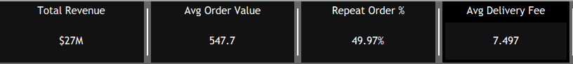

Business Q2 : Which cuisines and restaurant types contribute the most to total revenue?
Visualization Treemap
Attributes:
- Dimension: Cuisine
- Dimension: Restaurant Type
- Measure: Total Revenue
Screenshot:

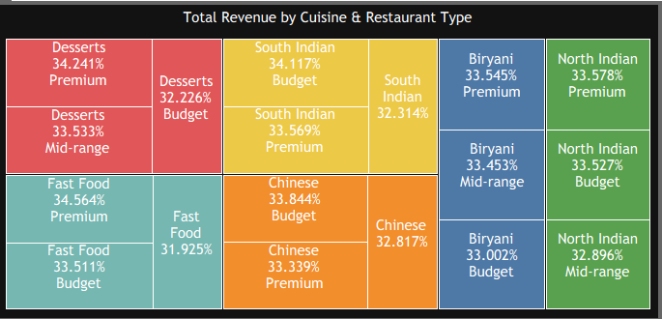

Business Q3 : How does repeat-order behaviour vary across different customer moods?
Visualization: 100% Stacked Bar Chart
Attributes:
- Dimension: Mood
- Measure: Repeat Order %
- Measure: Number of Orders
- Color: Repeat Order Status
Screenshot:

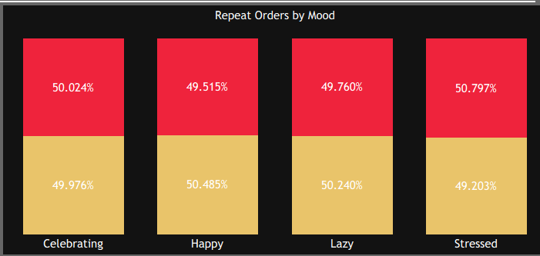

Business Q4 : How does order volume vary with delivery time?
Visualization: Dual-Axis Bar and Line Chart
Attributes:
- Dimension: Delivery Time
- Measure: Order Volume
- Measure: Delivery Time

Screenshot:

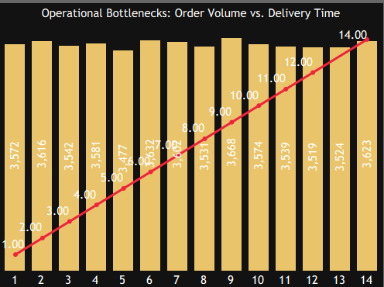

Business Q5 : How are weekday and weekend orders distributed across cities?
Visualization : Stacked Bar Chart
Attributes:
- Dimension: City
- Dimension: Day Type
- Measure: Order Count
- Color: Weekday / Weekend

Screenshot:

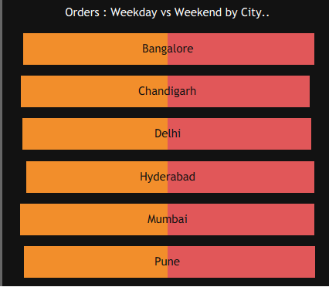

Business Q6 : How does rain affect delivery time and delivery fees?
Visualization : Box Plot / Distribution Chart
Attributes:
- Dimension: Rain / Weather Condition
- Measure: Delivery Time
- Measure: Delivery Fee

Screenshot:

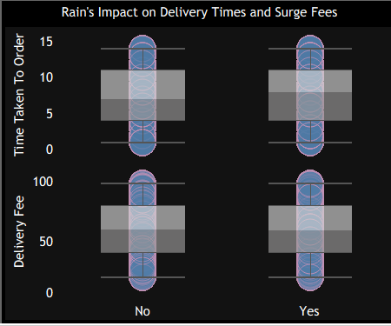

Business Q7 : Which cities generate the highest order volume?
Visualization: Ranked Horizontal Bar Chart
Attributes:
- Dimension: City
- Measure: Number of Orders
Screenshot:

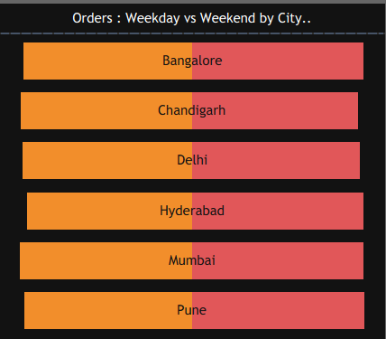

Business Q8 : Which cuisines are most preferred by customers?
Visualization: Treemap
Attributes:
- Dimension: Cuisine
- Dimension: Restaurant Type
- Measure: Total Revenue

Screenshot:


5. Dashboard
5.1 DASHBOARD DESIGN FILE

Activity 1: Interactive and Visually Appealing Dashboard
The Food Delivery Analytics: Customer Behaviour & Operational Insights Tableau dashboard is designed to provide an interactive analysis of food orders, customer behaviour, cuisine preferences, revenue, city-level demand, meal types, delivery performance, and customer satisfaction.
Dashboard Design Principle | Implementation in My Tableau Dashboard
Clear and Intuitive Layout | KPI cards are placed at the top, followed by visualizations for customer behaviour, cuisine preferences, revenue, city performance, and delivery operations.
Use Appropriate Visualizations | KPI cards, horizontal bar charts, stacked bar charts, heatmaps, donut charts, treemaps, and histograms are used based on the type of analysis required.
Colour and Theming | A consistent dark theme with contrasting colours is used to distinguish categories and highlight important metrics..
Interactive Filters and Slicers | Filters for City, Cuisine, and Meal Type allow users to interactively explore different segments of the food delivery data.
Drill-Down Capabilities | Users can analyze performance from an overall level to detailed views by city, cuisine, meal type, company, age group, and restaurant type.
Responsive Design | Dashboard components are arranged into logical sections to maintain readability and make comparisons between visualizations easier.
Custom Visuals and Icons | KPI cards and customized charts highlight important business measures such as orders, revenue, delivery fees, order value, and customer ratings.
Use of Infographic | Visual charts and graphical elements transform complex food delivery data into simple and understandable business insights.
Major Outcomes from the Dashboard
1. Overall Food Ordering Performance
The KPI cards provide a quick summary of the business performance, showing Total Revenue of $27M, Average Order Value of 547.7, Repeat Order Rate of 49.97%, and Average Delivery Fee of 7.497. These KPIs provide a high-level view of revenue, customer spending, repeat behaviour, and delivery costs.
2. Revenue by Cuisine and Restaurant Type
The treemap compares revenue contribution across different cuisines and restaurant types such as Desserts, South Indian, Fast Food, Chinese, Biryani, and North Indian. It helps identify the cuisine and restaurant segments contributing strongly to revenue.
3. Repeat Orders by Customer Mood
The 100% stacked bar chart compares repeat-order behaviour across different moods, including Celebrating, Happy, Lazy, and Stressed. The visualization shows that repeat-order percentages are relatively balanced across moods, with both repeat and non-repeat orders contributing approximately half of the orders.
4. Operational Bottlenecks: Order Volume vs. Delivery Time
The combined bar and line chart compares order volume with delivery time. It helps identify whether higher order volumes are associated with longer delivery times and highlights potential operational bottlenecks.
5. Weekday vs. Weekend Orders by City
The stacked bar chart compares weekday and weekend orders across Bangalore, Chandigarh, Delhi, Hyderabad, Mumbai, and Pune. This helps understand city-level ordering patterns and differences between weekday and weekend demand.
6. Rain's Impact on Delivery Time
The distribution chart compares delivery time under different rain conditions. It helps investigate whether weather conditions are associated with changes in delivery performance.
7. Rain's Impact on Delivery Fees
The same operational visualization also compares delivery fees under rain conditions, helping assess whether adverse weather is associated with changes in delivery charges.
8. City-level Demand Analysis
The city comparison section provides a view of ordering activity across major cities such as Bangalore, Chandigarh, Delhi, Hyderabad, Mumbai, and Pune. This helps stakeholders compare market demand and identify cities requiring greater operational or business attention.
9. Customer Behaviour Analysis
The dashboard combines Repeat Order %, Mood, and interactive filters to provide insight into customer ordering behaviour. This can help identify behavioural patterns that may be useful for customer retention and engagement strategies.
10. Interactive Decision Support
The dashboard provides interactive filters for City, Hunger Level, Repeat Order, and Meal Type. Users can select different combinations to investigate specific customer segments and understand how revenue, repeat ordering, delivery performance, and other metrics change.

DASHBOARD NO 1:

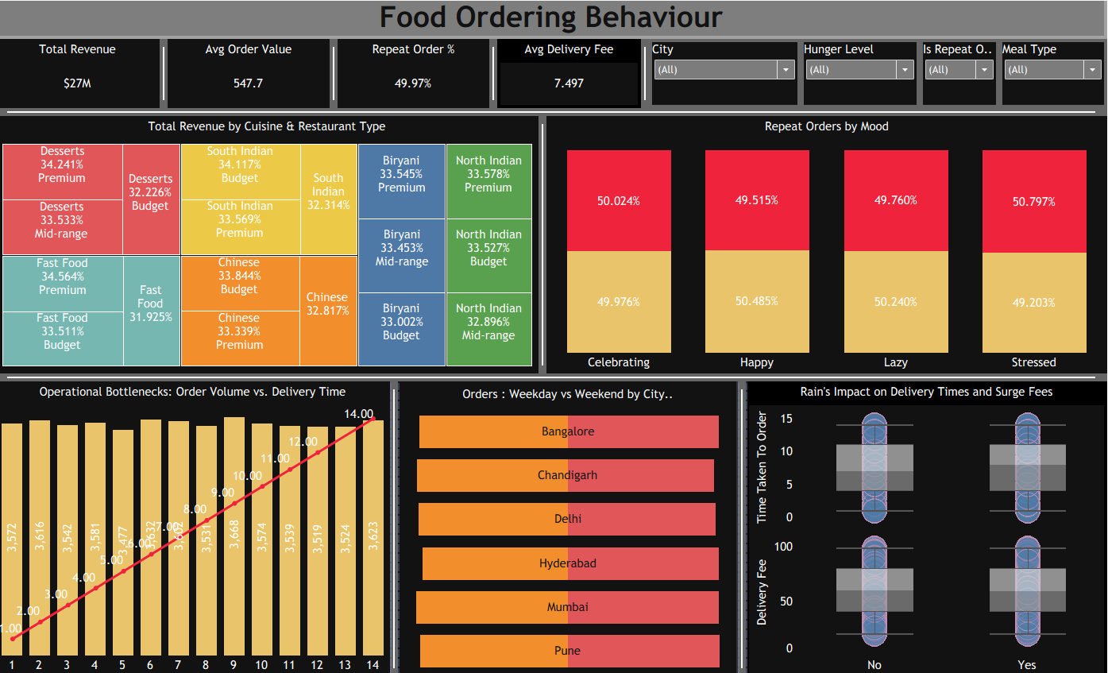

Tableau Public Dashboard Link:
https://public.tableau.com/app/profile/niranjan.patil7910/viz/FoodOrderingBehaviourN/FoodDelivery?publish=yes
Note: You need to publish your .twbx workbook to Tableau Public first and then paste the generated public URL in your project document.

6. Report

6.1 Story Design File

Data Story / Observations
The Tableau story presents the Food Ordering Behaviour analysis in a logical sequence, starting with overall business performance and moving toward city, cuisine, customer, meal-type, revenue, rating, and delivery-time analysis.
Observations:

1. Overall Food Ordering Performance

Chart: KPI Cards

The dashboard provides a quick overview of business performance through Total Revenue ($27M), Average Order Value (547.7), Repeat Order Rate (49.97%), and Average Delivery Fee (7.497).

2. Revenue by Cuisine and Restaurant Type

Chart: Treemap

The treemap compares revenue contribution across cuisines and restaurant types, helping identify which cuisine and restaurant segments contribute strongly to overall revenue.

3. Repeat Orders by Customer Mood

Chart: 100% Stacked Bar Chart

The visualization compares repeat-order behaviour across different moods such as Celebrating, Happy, Lazy, and Stressed. It shows that repeat-order percentages are relatively balanced across the different moods.

4. Operational Bottlenecks

Chart: Bar + Line Combination Chart

The chart compares order volume with delivery time. It helps identify locations or periods where delivery time may become an operational concern despite continued order demand.

5. Weekday vs Weekend Orders by City

Chart: Stacked Bar Chart

The visualization compares ordering behaviour between weekday and weekend across cities such as Bangalore, Chandigarh, Delhi, Hyderabad, Mumbai, and Pune.

6. City-Level Ordering Behaviour

Chart: Stacked/Comparison Bar Chart

The city analysis helps compare order patterns across different locations and identify cities with relatively higher or lower food-ordering activity.

7. Rain's Impact on Delivery Time

Chart: Box Plot / Distribution Chart

The visualization compares time taken to deliver orders under rainy conditions and helps identify variation in delivery performance.

8. Rain's Impact on Delivery Fees

Chart: Box Plot / Distribution Chart

The dashboard also examines delivery fees during rainy conditions, helping understand whether weather conditions are associated with differences in delivery charges.

9. Interactive Customer and Order Analysis

Charts: Dashboard Filter

the dashboard provides interactive filters for City, Hunger Level, Is Repeat Order, and Meal Type. Users can apply these filters to investigate specific customer segments and ordering patterns.

Story Flow
Story Point 1 → Overall Food Ordering Performance
Story Point 2 → Revenue by Cuisine & Restaurant Type
↓
Story Point 3 Repeat Orders by Mood
↓
Story Point 4 Operational Bottlenecks: Order Volume vs Delivery Time
↓
Story Point 5 Weekday vs Weekend Orders by City
Story Point 6 City-Level Ordering Behaviour
Story Point 7 → Rain's Impact on Delivery Time
↓
Story Point 8 → Interactive Customer & Order Analysis
Activity 2: Publish Story on Tableau Public
Tableau Public Story Link:

https://public.tableau.com/app/profile/niranjan.patil7910/viz/FoodOrderingBehaviourN/FoodOrderingBehavoirStory?publish=yes7.

Performance Testing

7.1 Utilization of Data Filters
- Applied global single-select and multi-select filters across dashboards (e.g., Cuisines, Restaurant Types, Weather Conditions, and Customer Mood) to minimize query processing overhead.
- Used context filters and optimized filter scope to ensure calculation updates apply only to relevant visual elements without causing full dataset recalculations.

7.2 Number of Calculation Fields
umber of Calculated Fields
- Created custom calculated fields in Tableau to compute core metrics, including Total Revenue, Average Order Value (AOV), Repeat Order %, Average Delivery Time, and Weather Surge Impact.
- Optimized calculated field formulas using aggregated measures to maintain fast workbook performance and quick dashboard rendering.

7.3 Number of Visualizations
- Built dedicated KPI summary cards to highlight high-level metrics such as Total Revenue, AOV, Repeat Order %, and Average Delivery Time.
- Constructed visual components across 4 interactive sprint views, including bar charts, line trends, scatter plots, and heatmaps to analyze operational bottlenecks, rain impact, customer mood, and cuisine performance.
8. Conclusion / Observation
- Spending patterns and total revenue vary across cuisine types and restaurant categories, identifying clear drivers for revenue expansion.
- Weather conditions, particularly rain, increase delivery duration and trigger surge fees, highlighting key operational friction points.
- Customer mood and order experiences correlate directly with repeat ordering behavior, demonstrating the value of targeted retention strategies.
- Consolidating operational and customer data into interactive Tableau dashboards significantly improves visibility for business decision-makers.

9. Future Scope
• Predictive Modeling: Incorporate machine learning models to forecast order demand, optimal surge pricing, and peak delivery delays based on real-time weather forecasts.
• Live Data Pipelines: Transition from static CSV files to live cloud database connections (e.g., PostgreSQL or Snowflake) for real-time operational tracking.
• Geospatial & Route Optimization: Integrate GIS spatial mapping to analyze exact delivery routes, driver distance, and hyper-local traffic congestion patterns.
• Customer Lifetime Value (CLV) Segmentation: Expand customer analysis to track CLV and automated personalized promotional offers based on order frequency and mood dynamics.

10.GitHub & Project Demo Link
GitHub Repository :
Link: https://github.com/niranjanpatil1122-tech/Food-Delivery-Analytics-Customer-Behavior-Operational-Insights.git

Tableau Public Dashboard:
Link : https://public.tableau.com/app/profile/niranjan.patil7910/viz/FoodOrderingBehaviourN/FoodDelivery?publish=yes

Tableau Public Story
Link :

https://public.tableau.com/app/profile/niranjan.patil7910/viz/FoodOrderingBehaviourN/FoodOrderingBehavoirStory?publish=yes7.

Project Demo Video:
Link: https://drive.google.com/file/d/1AOj5X9CTL-UA1IPN0n0Lv-4SIWcSs3qv/view?usp=sharing

